

Name – Divyansh Mishra
Registration No. – 25BAI11302
Email – divyansh.25bai11302@vitbhopal.ac.in
Project – Spam Message Detector

CONTENTS

- Problem Statement
- Requirements
- Algorithm
- Flowchart
- Codes and Implementation
- Resources

Problem Statement

To identify a real-world problem that genuinely interests you and solve it using the concepts, tools, and techniques of AI and ML.

Requirements

Functional Requirements
- The system must take the input about what message the user got.
- The system must read the message and verify whether it is a SPAM or not.
- The system must display the verified results.

Non-functional Requirements
- The program should be simple and user friendly.
- It should handle errors without crashing.
- Execution should be quick.

Algorithm
- Start the program
- Import libraries
- Import CountVectorizer
- Import MultinomialNB
- Create Dataset
- Store messages in a list
- Store corresponding labels (spam/ham)
- Convert text to numeric form
- Initialize CountVectorizer
- Transform messages into vectors (X)
- Train the model
- Initialize MultinomialNB
- Train model using X and lables.
- Start input user loop
- Ask the user to enter a message.
- Check exit condition
- If input = “exit”, go to step 10
- Process input
- Convert user message into vector.
- Predict using trained model.
- Display result
Print “spam” or “ham”
Go back to step 6
- Stop.
Flow Chart

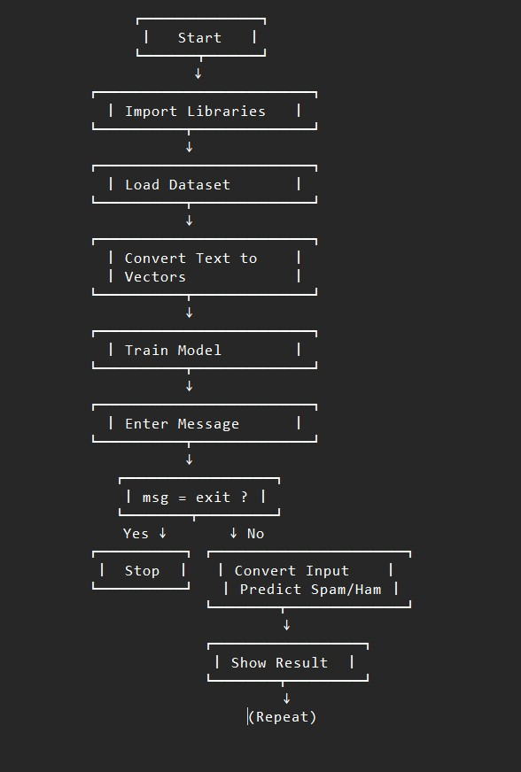
Code & Implementation

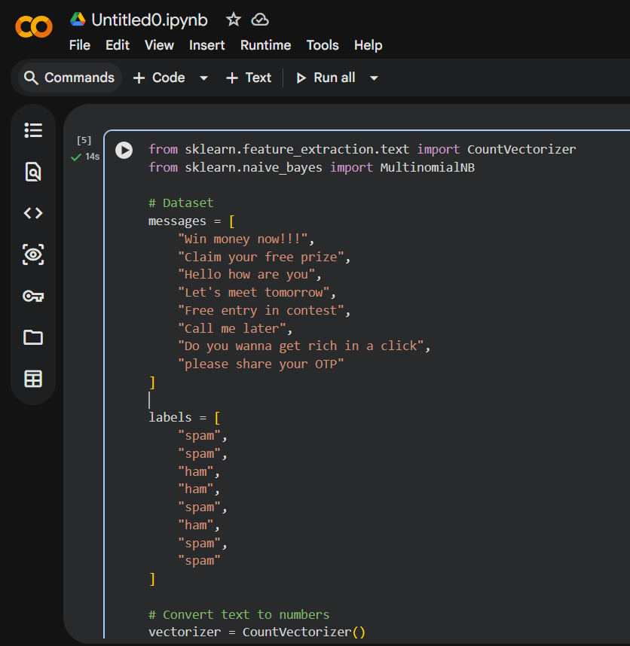

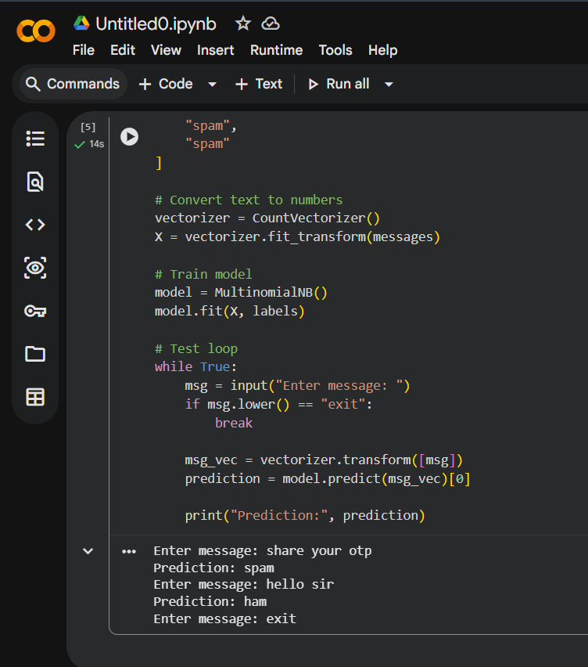

Resources

- Python Programming Language
Used to write the entire program and handle user input, loops, error handling, and function creation.

- Requests Library (Python)
This library was used to send HTTP requests.

- VS Code (Visual Studio Code)
Used as the code editor to write, edit, and run the Python program.

